CAS PY 106

Prelecture Note 20

1. Lenz’s Law
2. Exposing a coil or loop to a changing magnetic flux will generate a current if the circuit is complete (Faraday’s Law – there is an induced voltage that is produced whenever there is a change in magnetic flux)
3. Direction of the current is given by Lenz’s Law
4. Lenz’s Law: A changing magnetic flux induces an emf that produces a current which sets up a magnetic field that tends to oppose whatever produced the change 🡪 why there is a negative sign in the Faraday’s Law
5. Lenz’s Law is consistent with energy conservation 🡪 if we move a magnet near a coil, for instance, the work we do to move the magnet against the resistive force of the coil is converted to electrical energy, which could be used to light a light bulb
6. Coils and loops don’t like to change, and they will try to counteract any changes in magnetic flux imposed on them
7. They are not successful – the change can be made but the coil or loop tries to oppose the change while the change is taking place. This tendency to oppose is why there is a minus sign in Faraday’s Law
8. Pictorial approach to Lenz’s Law
9. Easy way to approach Lenz’s Law situations, to figure out the direction of an induced current, it to draw a set of three pictures
10. Direction of the magnetic field inside a loop if loop has counter-clockwise or clockwise current
11. 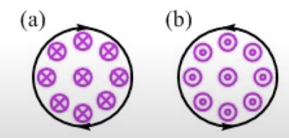
12. Ex) Wire loop in the plane of the page is in a uniform magnetic field directed into the page. Over some time interval, the field is doubled (change the flux within the loop). What direction is the induced current in the loop while the field is changing
13. Step 1: Draw a “Before” picture, showing the field passing through the loop before the change takes place



1. Step 2: Draw an “After” picture, showing the field passing through the loop after the change



**Note**: Field lines drawn on “Before” and “After” pictures are produced by something external to the loop itself

1. Step 3: Draw a “To Oppose” picture, showing the direction of the field the loop creates to oppose the change



**Note**: Field lines shown in the “To Oppose” picture is produced by the loop itself, through the induced current

1. Step 4: Use the right-hand rule to determine which way the induced current goes in the loop to create the field

Our field line is enough for the “To Oppose” picture – that’s enough to determine the direction of the induced current